Linux Filesystem
Date - 16/03/2026 Full Name - Misty Maken

Introduction to Linux Filesystem

The Linux File System is a way of organizing and storing data on a Linux system. It arranges files in a hierarchical directory structure that begins from the root directory (/).Unlike operating systems like Windows, Linux treats everything as a file - whether it's a directory, a hardware device, or even an active process.
The system follows a tree-like structure, which makes it easy to navigate and manage files.
Certain directories such as /home, /etc, /bin, and /var have specific roles in the operating system.

Key features of Linux Filesystem
- Hierarchical Directory Structure
The Linux file system follows a hierarchical tree structure that begins from the root directory (/). All files and directories are organized under this root, which makes navigation and file management systematic.
- Everything is Treated as a File
In Linux, most system components such as regular files, directories, hardware devices, and some system resources are represented as files. This simplifies system interaction and management.
- Multi-User Support
Linux supports multiple users working on the same system simultaneously. Each user has a separate home directory and controlled access to system resources.
- File Permissions and Security
The Linux file system provides a strong permission system that controls access to files and directories through read, write, and execute permissions assigned to owners, groups, and other users.
- Support for Multiple File System Types
Linux supports several file system formats such as ext4, XFS, and Btrfs, allowing flexibility and compatibility with different storage devices and performance requirements.
- Mounting of File Systems Linux allows different storage devices, such as external drives and network storage, to be mounted within the directory structure. Once mounted, these devices become accessible as part of the main file system.

Directory structure
The Filesystem Hierarchy Standard (FHS) defines the directory structure and directory contents in Linux systems. Linux/Unix operating system, files are stored in a tree-like structure starting with the root directory. Every file and directory in the system is located somewhere under this root. Major directories in Linux include:
- /bin - Contains essential binary or executable programs required for basic system operation.
- /etc - Stores system-wide configuration files used to control system behavior.
- /home - Contains user home directories and serves as the default working directory for users.
- /opt - Holds optional or third-party software packages installed separately from the system.
- /tmp - Provides temporary storage space for files, which is typically cleared on system reboot.
- /usr - Contains user-related programs, utilities, and shared resources. (Subdirectories include: /usr/bin, /usr/lib, /usr/share)
- /var - Stores variable data such as log files that change frequently during system operation.
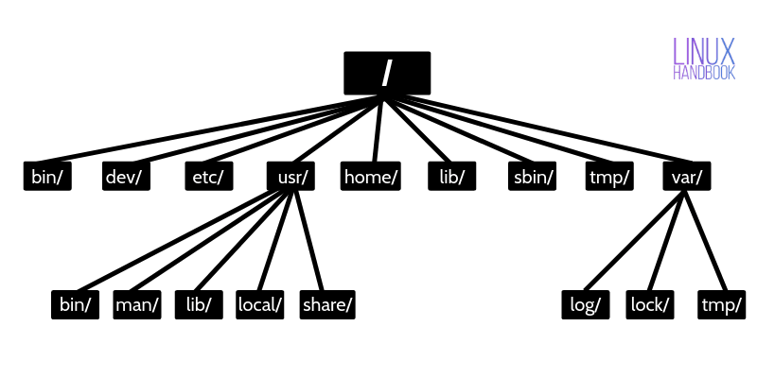
Permission and access to files: Linux employs a robust permissions system that controls access to files and directories. Each file has three sets of permissions for the owner, the group, and others:
- Read (r): Permission to read the contents of the file.
- Write (w): Permission to modify the file.
- Execute (x): Permission to execute the file as a program.
Essential Linux Commands

ls (List) : Shows the files and directories in the current directory. (syntax: ls [options] [directory])
- pwd: Displays the current directory path you are in. (syntax: pwd)
- mkdir (Make Directory): Creates a new directory. (syntax: mkdr directory_name)
- cd (Change Directory): Used to change the current working directory and helps us navigate between directories. (syntax: cd directory_name)
- rmdir (Remove Directory): Allows the user to delete empty directories i.e ones that dont contain any files. (syntax: rmdir directory_name)
- cp : Used to copy files or directories. It is useful to create a backup. (syntx: cp source destination)
- mv : This move command is used to move or rename files between directories in Linux. (syntax: mv old_name new_name)
- rm : The rm command is used to delete a file permanently thus freeing up disk space ( syntax: rm file_name)
- uname: The uname command in Linux is used to display system information. It shows operating system details and help identify the system. (syntax: uname)
- locate: The locate command helps us find files using a database quickly. (syntax: locate file_name)
- touch: Empty files are created using the touch command (syntax: touch file_name)
- ln : The ln command is used to creat link between files. It creates shortcuts to links and supports hard and soft links. (syntax: ln -s source link_name)
- cat: We can view file content using the cat command in Linux. It reads file contents and combines multiple files. (syntax: cat file_name)
- clear: used to clear the Linux terminal screen and wipes out the previous outputs (syntax: clear)
- whoami : Shows the current logged in user (syntax: whoami)
- wget : We can download files from the internet using the wget command on Linux. It downloads the file using a URL (syntax: wget url)
- sort: The sort command is used to sort the file contents (syntax: sort file_name)
- echo : The echo command in Linux is used to display text in the terminal. It helps print messages and writes text into files (syntax: echo “text”)
- man : User can display command manuals using the man command. It provides command documentations and explains options and usage (syntax: man command_name)
- df: Used to display disk space used. (syntax: display [options])

Sources:
https://www.geeksforgeeks.org/linux-unix/basic-linux-commands/
https://www.geeksforgeeks.org/linux-unix/linux-directory-structure/
https://dev.to/prodevopsguytech/understanding-the-linux-filesystem-an-in-depth-guide-for-devops-engineers-ona

